Problem statement:

Prepare support vector machines model for classifying the area under fire for foresfires data.

Data visualization:

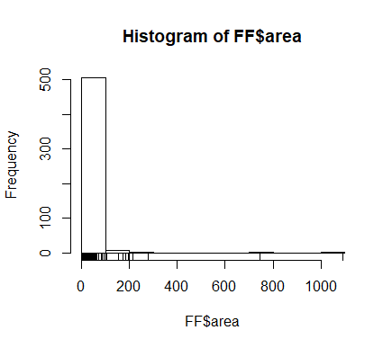

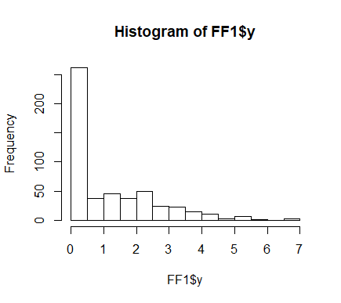

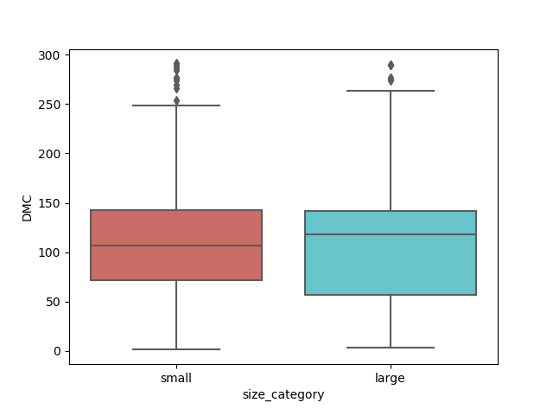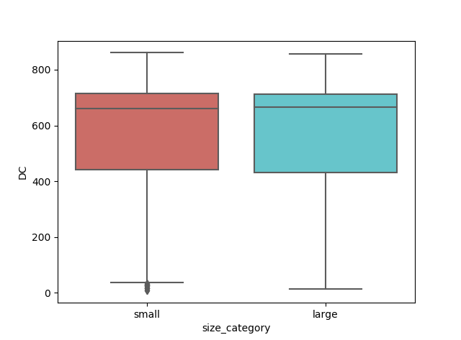

The area value has lots of zeros.

Prediction of Forest fires requires only prediction from temperature, rain, relative humidity and wind speed.

Apply Normalization technique to the whole dataset.

Use different types of kernels to get high accuracy rate

Different types of kernels:

"rbfdot", "polydot", "tanhdot", "vanilladot", "laplacedot",

"besseldot", "anovadot", "splinedot", "matrix"

Accuracies for different kernels:

Rbfdot kernel accuracy=0.6849315

Vanilladot kernel accuracy=0.6780822

Basseldot kernel accuracy=0.6780822

Polydot kernel accuracy=0.6780822

Problem statement:

Prepare a classification model using SVM for salary data.

Load the data:

As there are two datasets train and test separately load the both datasets seperately.

Preprocessing the data:

As, there are categorical variables pre-process the data and normalize the values.

Model building:

Build the model and change the kernels for getting different accuracies of the model.

model1<-ksvm(train_sal$Salary~.,data= train_sal, kernel = "vanilladot")

model1

=>prop.table (table(agreement))

#agreement

#FALSE TRUE

#0.1535857 0.8464143

kernel = **rfdot**

Accuracy=0.8520584

kernel = **vanilladot**

Accuracy=0.8464143

kernal = **besseldot**

Accuracy=0.7897078

kernel = **polydot**

Accuracy=0.8461487